Technical Report: Satellite-Based Slum Detection Pipeline for Mumbai Urban Analysis
Dataset link:https://www.kaggle.com/datasets/rupeshkumaryadav/mumbai-slum-detection-dataset

1. Project Overview and Strategic Objectives
In the high-density, hyper-dynamic urban environment of Mumbai, traditional manual mapping of informal settlements slums is inherently reactive and prone to obsolescence. For urban planners and humanitarian organizations, the ability to monitor these settlements in near-real-time is critical for infrastructure deployment and crisis response. This project establishes an automated semantic segmentation pipeline that leverages deep learning to identify slum boundaries within satellite imagery, providing a scalable and objective alternative to labor-intensive ground surveys.
The strategic objective of this pipeline is to ingest raw, multi-spectral satellite data and produce high-fidelity binary masks using a ResNet-34 UNet architecture. By transforming complex spectral signatures into actionable spatial intelligence, we enable a proactive approach to urban analysis. However, converting raw geospatial data into a format suitable for deep learning requires a sophisticated data engineering strategy to address the unique constraints of satellite imagery.

2. Data Engineering and Preprocessing Methodology
Raw satellite scenes are typically too large to be processed directly by neural networks and possess spectral characteristics that differ significantly from standard computer vision datasets. To maintain spatial consistency and computational efficiency, a standardized "chipping" strategy is utilized, breaking the original (4, 3954, 2105) Sentinel-2 input into manageable tiles.

Chipping and Augmentation Strategy
The imagery is processed into chips of 256x256 pixels using a stride of 64.
- The "So What?": This significant overlap (75%) serves as a primary data augmentation mechanism, providing the model with multiple spatial views of the same urban features. The 256x256 dimensions provide sufficient local context to distinguish the characteristic high-density roof textures of informal settlements from formal residential or industrial structures.

Strategic Band Selection and Normalization
A critical trade-off was made regarding spectral depth. While the raw sentinel_input.npy contains four bands (likely including Near-Infrared), the pipeline selects only the first three bands (RGB).
- The Strategic Trade-off: By discarding the fourth band, we sacrifice potential spectral indices like NDVI (Normalized Difference Vegetation Index). However, this allows the use of ImageNet-pre-trained weights for the ResNet-34 encoder. In urban morphology tasks, the structural features learned from millions of natural images often prove more valuable than the additional spectral band.
- Normalization: Unlike standard Z-score normalization (mean/std subtraction), this pipeline employs a min-max scaling approach: image / (image.max() + 1e-8). This ensures that the high-bit depth satellite data is compressed into a 0-1 range, providing the numerical stability required for an ImageNet-optimized backbone.

Class Imbalance and Data Split
To prevent the model from converging on a trivial "all-black" solution a common failure mode in geospatial AI where the target class is sparse we implement a strict filtering rule: only chips containing slum pixels are retained. This focuses the training cycle on feature differentiation rather than background rejection.
The resulting dataset is split according to a 70/15/15 distribution:
- Train: 70% (Weight optimization)
- Validation: 15% (Hyperparameter tuning and checkpoint selection)
- Test: 15% (Unseen data for final performance audit)

3. Model Architecture and Training Configuration
The pipeline utilizes a UNet architecture with a ResNet-34 backbone. This hybrid approach combines the deep feature extraction and residual learning of ResNet with the symmetrical decoder of UNet, which is essential for recovering fine-grained spatial boundaries lost during downsampling.
Attribute | Specification
Encoder | ResNet-34 (Pre-trained on ImageNet)
Input Channels | 3 (RGB)
Loss Function | Dice Loss (Binary)
Optimizer | Adam (Learning Rate: 0.0001)
Training Duration | 30 Epochs
The "So What?" of Dice Loss: Standard Cross-Entropy loss can be biased by the background-to-foreground pixel ratio. Dice Loss directly optimizes for the Intersection over Union (IoU), forcing the model to prioritize the overlap between predicted and ground-truth masks. This is particularly effective in slum detection where boundary precision is the primary metric of success.

4. Training Progression and Performance Validation
Effective convergence is verified by monitoring the relationship between training and validation metrics. A model that captures the underlying urban morphology will show a steady decline in validation loss alongside rising accuracy scores.

Quantitative Analysis
The training logs reveal a highly effective learning curve. The Validation Loss descended from 0.6741 (Epoch 1) to its absolute minimum of 0.0857 at Epoch 28.
The performance growth across both training and validation sets is detailed below:
- Train IoU Growth: 0.2274 (Epoch 1) → 0.8559 (Epoch 28)
- Train F1 (Dice) Growth: 0.3584 (Epoch 1) → 0.9222 (Epoch 28)
- Validation IoU Growth: 0.3236 (Epoch 1) → 0.8530 (Epoch 28)
- Validation F1 (Dice) Growth: 0.4878 (Epoch 1) → 0.9205 (Epoch 28)
The close alignment between training and validation metrics (e.g., ~0.92 F1 for both) indicates high generalization and minimal overfitting. While the Adam optimizer caused minor fluctuations toward the end of the 30-epoch cycle (notably at Epoch 30, where Val Loss rose to 0.1031), our "save best model" logic successfully captured the optimal weights from Epoch 28.

5. Qualitative Results and Inference Capability
Final verification is conducted through a visual inference pipeline. Using the best_slum_model_rgb.pth weights, the system processes unseen test data through a sigmoid activation and a 0.5 probability threshold to generate binary output masks.

Visual Assessment and Global Scalability
The qualitative output, visualized in a three-column comparison (RGB Input, True Mask, Prediction), confirms that the model accurately delineates the irregular, dense clusters of informal settlements. The high final F1 score (~0.92) demonstrates that the system is robust enough for deployment.
Strategic Implications: Beyond the immediate analysis of Mumbai, this ResNet-34 UNet pipeline possesses high generalization potential. The structural features it identifies are characteristic of informal settlements in many global megacities, suggesting it could be deployed across diverse urban morphologies with minimal fine-tuning. Furthermore, this automated approach enables temporal analysis: by processing satellite feeds month-over-month, policymakers can monitor settlement growth or contraction in real-time, providing a level of oversight that manual mapping cannot achieve. This pipeline stands as a mature, deployable asset for geospatial urban intelligence.

Technical Case Study: Deep Learning Framework for Urban Slum Detection in Mumbai

1. Project Overview and Strategic Objective
In the rapidly evolving landscape of urban development, accurately identifying and mapping informal settlements is a critical prerequisite for effective city planning and equitable resource allocation. Densely populated megacities like Mumbai present a unique challenge for traditional surveying methods due to their vast scale and intricate structural complexity. This project addresses the data gap by utilizing high-resolution Sentinel satellite imagery, leveraging automated geospatial analysis to identify patterns that are often indistinguishable at the ground level.
The strategic mission of this initiative is the development of a ResNet-34 UNet segmentation model designed to map slum clusters with high precision. By employing deep learning, the framework transforms raw spectral data into actionable binary masks, providing a scalable solution for humanitarian monitoring. This curated dataset provides the high-entropy signal necessary to train the ResNet-34 UNet architecture to resolve high-frequency spatial features within Mumbai’s complex urban fabric.

2. Data Engineering: From Raw Sentinel Imagery to Model-Ready Chips
Raw satellite data is inherently unsuitable for direct ingestion into deep neural networks. Large-scale Sentinel arrays—such as the (4, 3954, 2105) tensors utilized in this study exceed standard GPU memory constraints and contain vast swaths of non-target data. Transformation is required to decompose these massive arrays into manageable, standardized inputs that accentuate the semantic features of informal settlements.
The data preparation phase utilizes a "Chipping" methodology to divide the full imagery into smaller sub-sections. We selected a CHIP_SIZE of 256 pixels to balance local spatial context with computational throughput, while implementing a STRIDE of 64 pixels to ensure significant overlap. This overlap serves as a critical data augmentation technique, ensuring that urban features appearing near the boundaries of one chip are fully captured in the center of subsequent windows.
A vital optimization in this pipeline is the filtering mechanism that only persists chips where the slum mask contains at least one positive pixel (mask_chip.max() > 0). This decision is fundamental to addressing Class Imbalance. In geospatial datasets of megacities, the "No Slum" class (comprising formal housing, infrastructure, and water) often outweighs the "Slum" class by a ratio exceeding 100:1. Without this filtering, the model would likely converge on a trivial solution—predicting "no slum" for every pixel—while still achieving misleadingly high accuracy. By forcing the network to train exclusively on chips containing target features, we ensure it learns to differentiate specific spectral signatures from background noise.
The preprocessing further refines the data through targeted band selection and advanced normalization:
- Band Selection: While the raw imagery contains 4 bands (likely including Near-Infrared), we down-select to the first 3 bands (RGB). This is a strategic architectural constraint required to satisfy the input requirements of the imagenet pretrained encoder.
- Normalization: A per-channel technique is applied where each chip is scaled to a 0–1 range. Crucially, an epsilon value of 1e-8 is added to the denominator (image / (image.max() + 1e-8)) to ensure numerical stability and prevent division-by-zero errors in regions with zero-reflectance.
The resulting dataset was partitioned into three distinct subsets to facilitate robust training and unbiased performance evaluation:
Dataset Split | Count
Training | 757
Validation | 162
Testing | 163
This rigorous data engineering pipeline ensures the model is fed a high-quality signal, setting the stage for the complex feature extraction handled by the architecture.

3. Architectural Framework: The ResNet-34 UNet Paradigm
Detecting irregular urban structures requires an architecture capable of identifying fine-grained textures while simultaneously reconstructing the precise spatial semantics of those features. This project utilizes the ResNet-34 UNet paradigm, which creates a powerful synergy between the deep feature extraction of Residual Networks and the localized reconstruction capabilities of the UNet.
Constructed via the segmentation-models-pytorch library, the model features a resnet34 encoder initialized with imagenet weights. This transfer learning approach allows the model to leverage a sophisticated understanding of shapes, edges, and gradients derived from millions of natural images. This encoder is coupled with a UNet decoder that utilizes skip connections, passing high-resolution spatial information directly to the final prediction layers to prevent the loss of detail during downsampling.
For the optimization objective, the framework employs DiceLoss (binary mode). This choice is superior to standard cross-entropy for urban segmentation because DiceLoss is mathematically derived from the F1-score. By optimizing for the overlap between the prediction and the ground truth, the model becomes highly resilient to the localized nature of slum clusters, effectively penalizing false positives and false negatives in a way that aligns directly with our primary evaluation metrics.

4. Optimization Strategy and Training Execution
A high-performance architecture requires a calibrated optimization strategy to ensure convergence without overwriting the valuable features acquired during pretraining. Rigorous metric tracking throughout the execution allows us to identify the most generalizable version of the weights.
The training execution was defined by the following parameters:
- Optimizer: Adam optimizer with a learning rate of 0.0001. This low learning rate is essential when using pretrained weights to avoid "catastrophic forgetting," a phenomenon where aggressive weight updates destroy the useful feature extractors inherent in the ImageNet-trained encoder.
- Duration: 30 Epochs.
- Hardware: Execution on CUDA-enabled hardware for accelerated tensor operations.
Performance was gauged using three primary metrics:
- Intersection over Union (IoU / Jaccard Index): The "gold standard" for geospatial accuracy, IoU measures the ratio of intersection to union. It is more punishing than the F1-score, providing a strict assessment of spatial overlap.
- F1 Score (Dice Coefficient): This metric balances precision and recall, serving as the primary measure of how well the model identifies slums while minimizing false detections.
- Validation Loss: The primary metric for saving the "Best Model," indicating the minimization of the optimization objective on unseen data.
These metrics provide a multidimensional view of the model’s evolution, leading to a granular analysis of the training trajectory.

5. Empirical Performance Analysis: Evaluating the Training Log
The training logs reveal a clear trajectory of improvement as the model refined its weights to the specific textures of Mumbai's informal settlements. The journey from the initial epoch to the final stages demonstrates a significant leap in predictive capability.
At the onset (Epoch 1), the model showed rudimentary understanding with a Val Loss of 0.6741 and a Val IoU of 0.3236. As the weights were fine-tuned, the "Best Model" was achieved at Epoch 28, where the Val Loss reached its nadir at 0.0857. Analysis of the final steps shows a slight fluctuation in Epoch 30, where the Val Loss rose to 0.1031. Given that the training loss continued to decline or remained stable, this represents a classic "overfitting" inflection point, confirming the strategic importance of our checkpointing system that preserved the state from Epoch 28.
The final achieved performance benchmarks at the peak (Epoch 28) demonstrate high-value accuracy:
- Validation IoU: 0.8530
- Validation F1 Score: 0.9205
This numerical success confirms that the model is highly capable of identifying complex slum structures, effectively bridging the gap between raw spectral data and geospatial intelligence.

6. Visual Validation and Inference Outcomes
While numerical metrics provide a macro-level view of performance, qualitative assessment via visual validation is essential to confirm that the model's spatial reasoning aligns with the real-world urban fabric.
The visualization pipeline generates a comparative analysis of three components:
- RGB Input: The spectral data processed into the visible spectrum for human inspection.
- True Slum Mask: The ground-truth labels indicating known informal settlements.
- Model Prediction: The binary output generated by the ResNet-34 UNet.
During inference, the model’s raw output passes through a sigmoid() activation function to convert scores into probabilities. A threshold of 0.5 is then applied to derive the final binary mask. The resulting visualizations demonstrate the model's success in generating masks that mirror the ground truth with high fidelity, successfully isolating the irregular, dense patterns of Mumbai's slums from surrounding formal infrastructure.
This framework represents a robust and effective methodology for geospatial analysis. Given the scale of Mumbai’s urban challenges, the high IoU scores and visual accuracy achieved here demonstrate a system ready for deployment in real-world urban planning and humanitarian monitoring contexts.

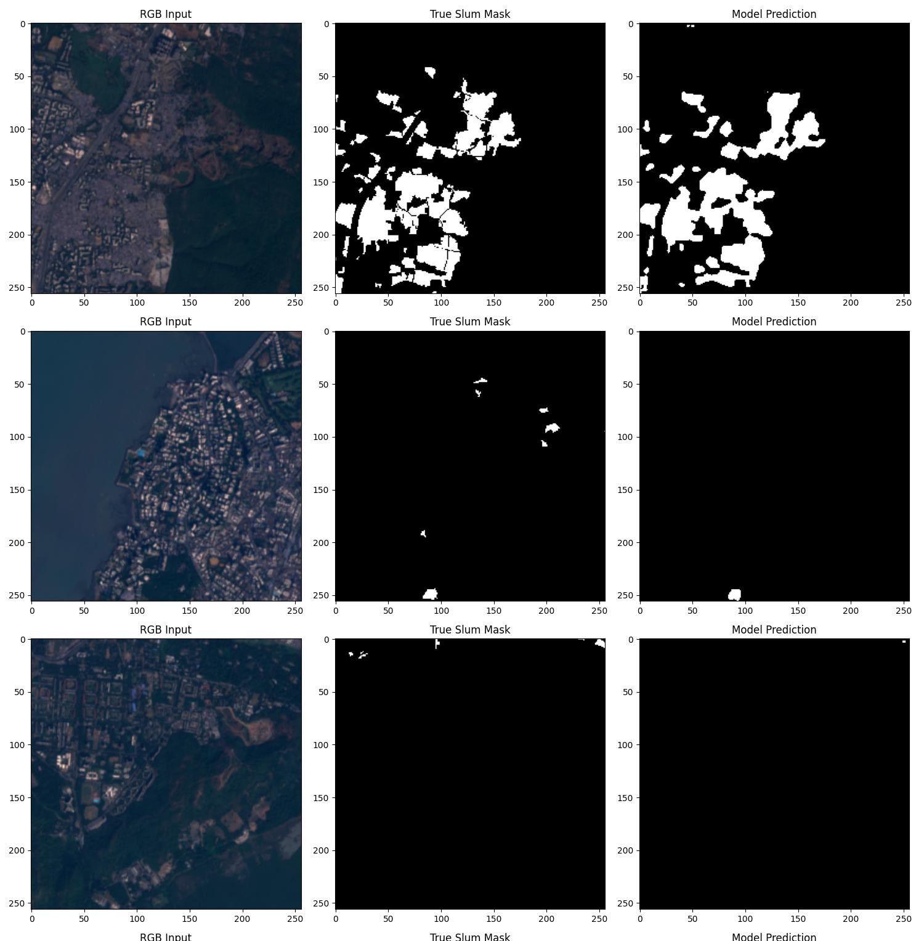

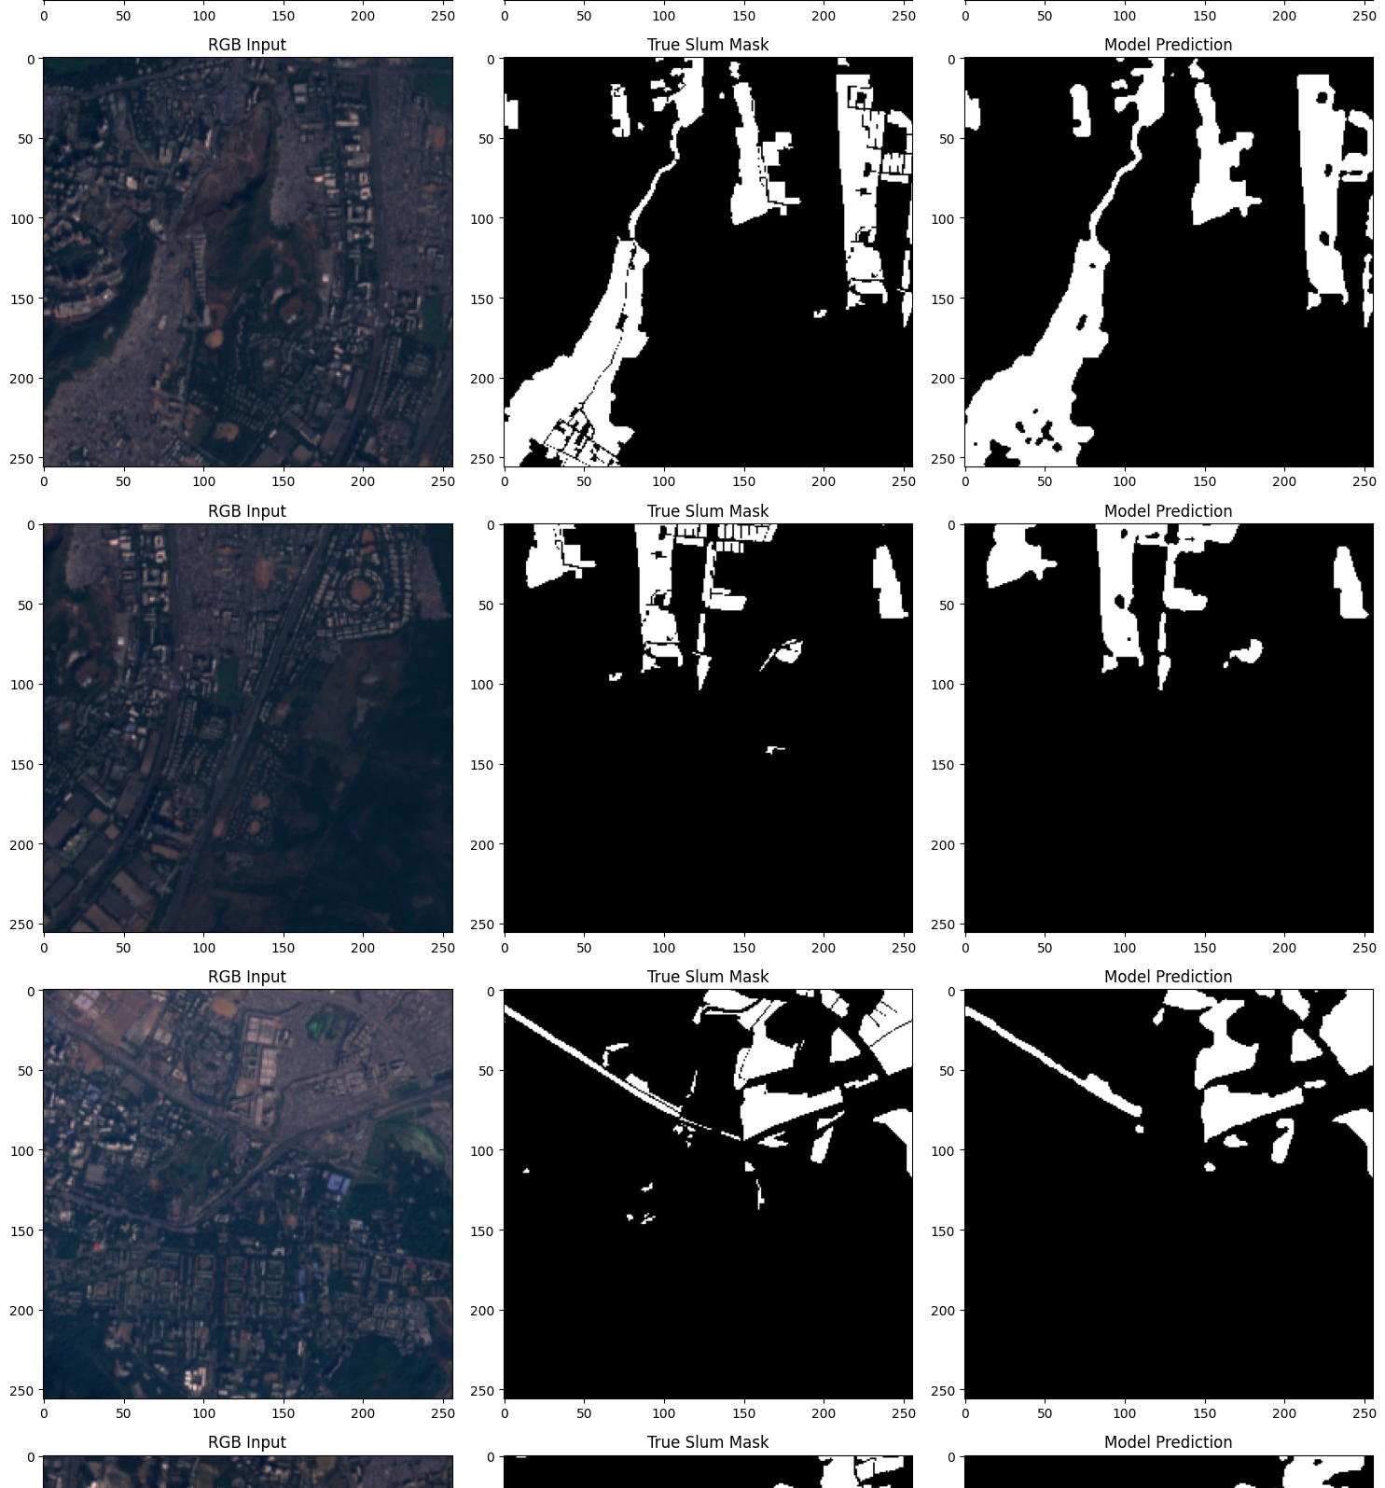
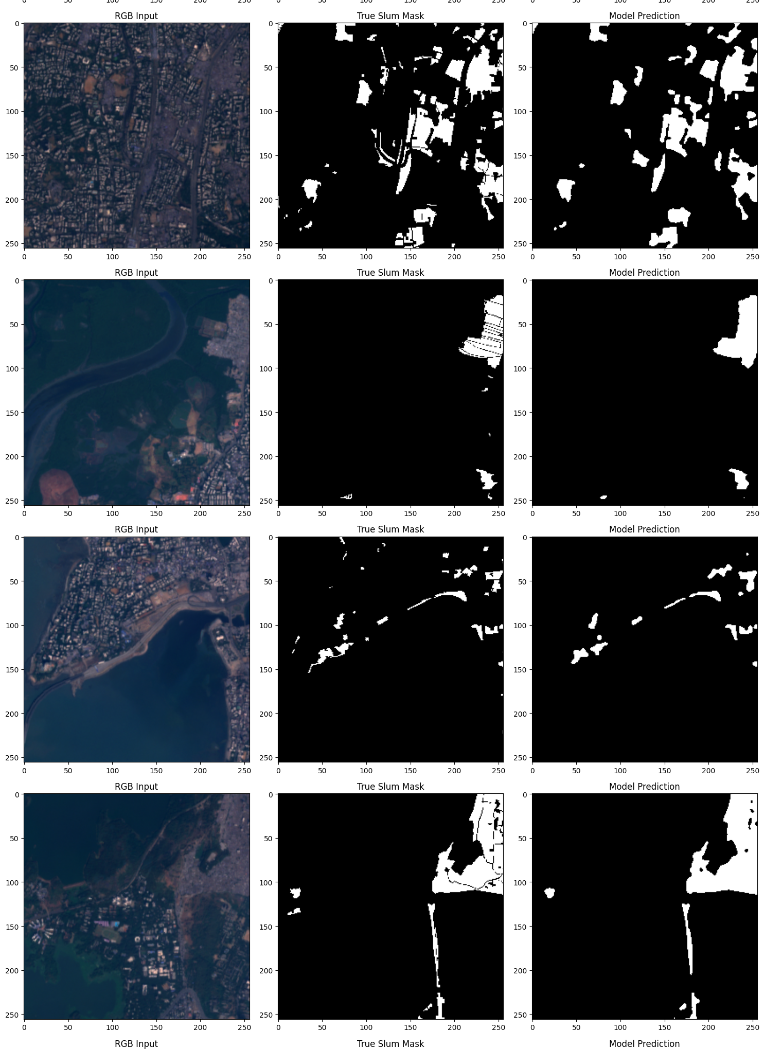



The model's performance on the Test Set is strong, as evidenced by the following key metrics:
- Average IoU (Intersection over Union): 0.8455
- Average F1 Score: 0.9160
- Average Loss: 0.0909

